Graphs and Transformations - Questions
May 2016 Mathematics Advanced Paper 1: Pure Mathematics 1

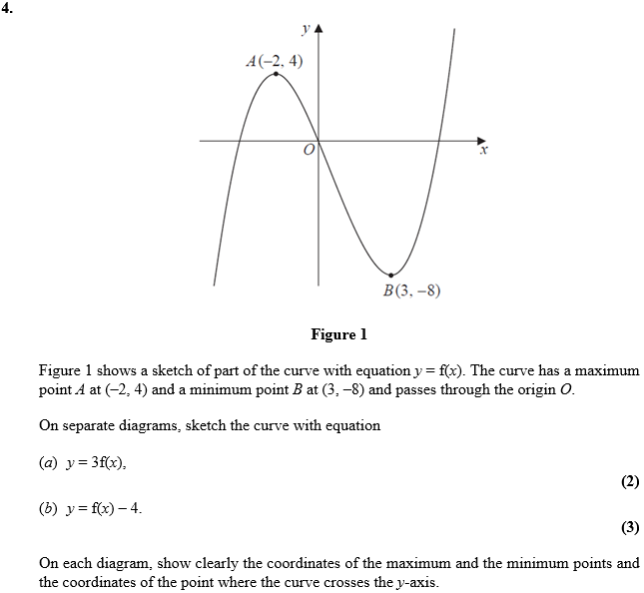

May 2014 Mathematics Advanced Paper 1: Pure Mathematics 1

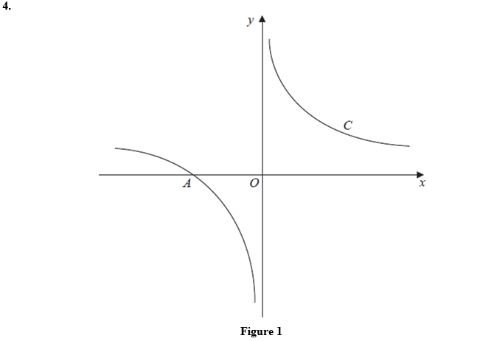
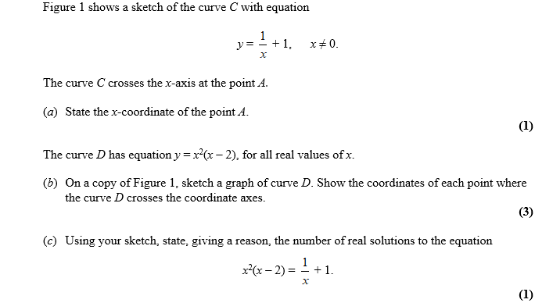

May 2013 Mathematics Advanced Paper 1: Pure Mathematics 1

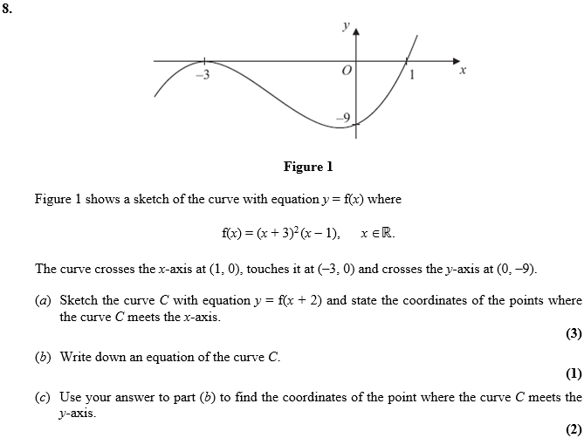

Jan 2013 Mathematics Advanced Paper 1: Pure Mathematics 1

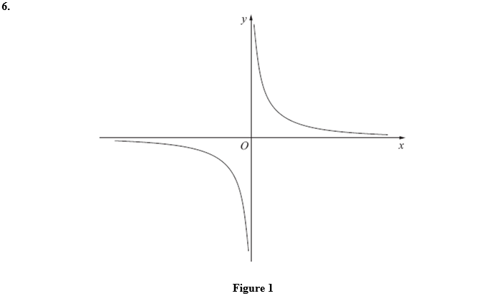
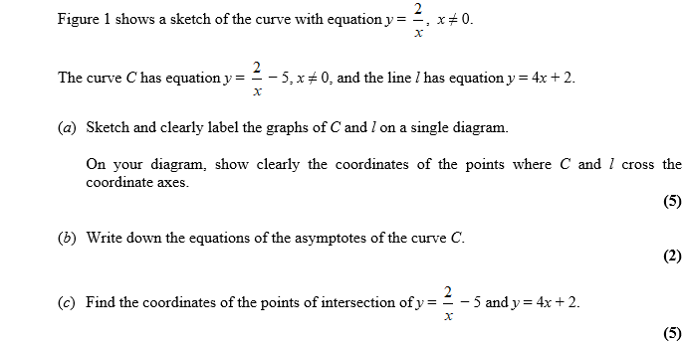

May 2012 Mathematics Advanced Paper 1: Pure Mathematics 1

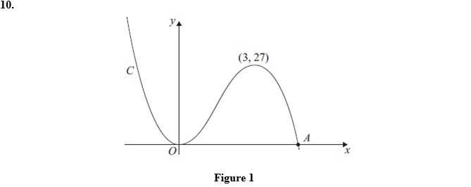
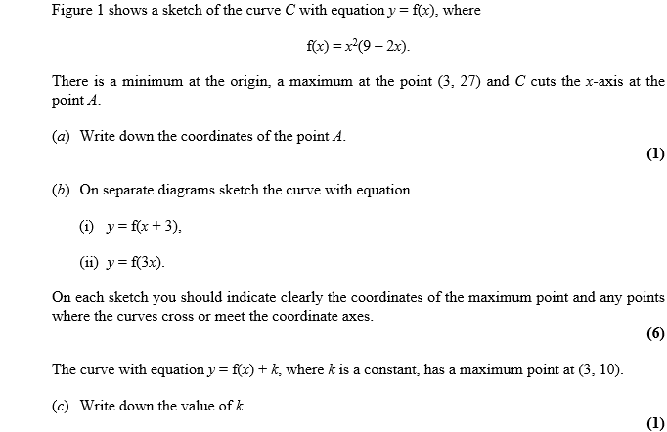

May 2011 Mathematics Advanced Paper 1: Pure Mathematics 1

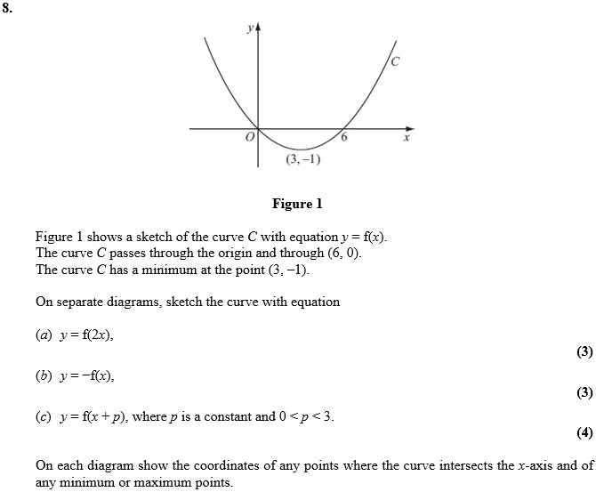

Jan 2011 Mathematics Advanced Paper 1: Pure Mathematics 1

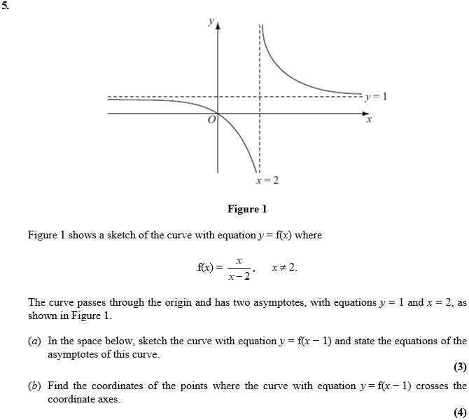

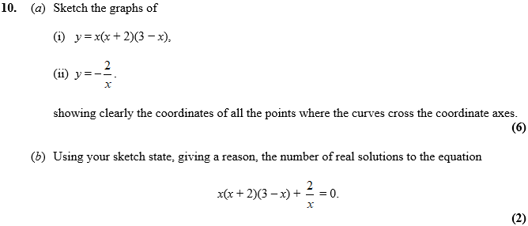

May 2010 Mathematics Advanced Paper 1: Pure Mathematics 1

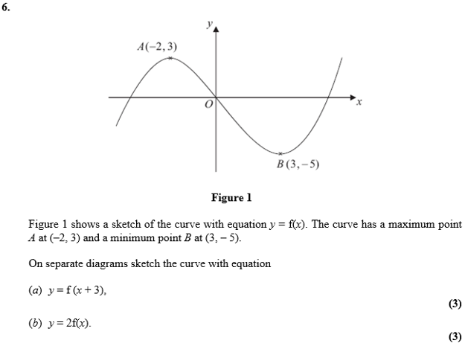
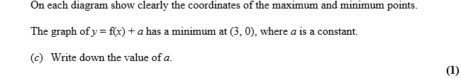

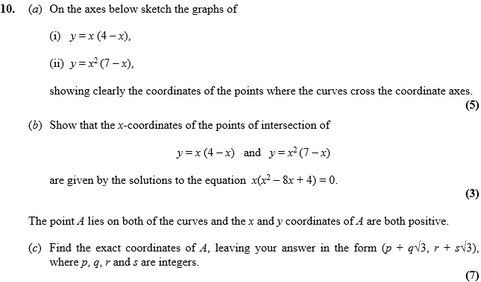

Jan 2010 Mathematics Advanced Paper 1: Pure Mathematics 1

